



admin review guide - approvals
This user guide steps through all functionality for the review process in the Approvals module.

Table of Contents
1. Introduction 2
2. Access and overview 2
3. Disclosures overview and export disclosures 3
4. Receive & manage disclosures 4
4.1. What's in a disclosure 5
4.2. Manage disclosure access 7
4.3. Review disclosures and decisions 11
4.3.1. Acknowledge/accept and forward 14
4.4. Reopen disclosures 16
4.5. Override disclosures 17
4.6. Further actions 17
4.7. Anonymization of disclosures 19

Introduction
The Approvals module helps you manage disclosures (gifts, invitations, conflicts of interest, etc.) easily within your organization. Employees can submit any relevant disclosures through a user-friendly employee portal and are then routed to approvers for review.

Access and overview
- You can access Approvals via Compliance Cockpit. From the Compliance Cockpit dashboard, click on ‘Approvals’ in the module list
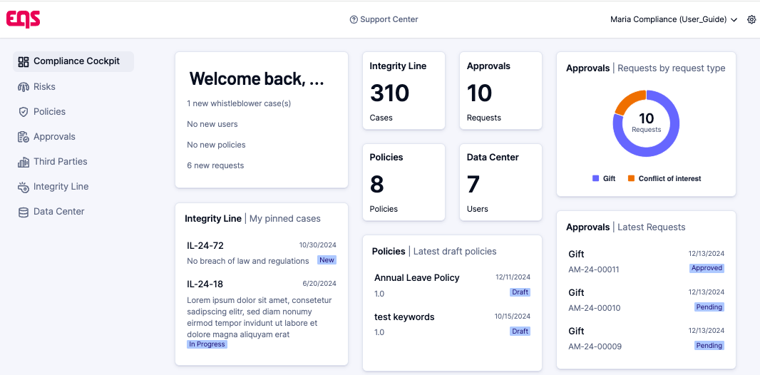
- From any page in Compliance Cockpit, open the ‘navigation menu’ (top left) to access the list of modules.
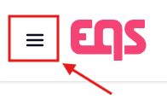
- You can also easily navigate to the Compliance Cockpit when you are logged in to Integrity Hub (employee portal) via the profile dropdown in the top-right of your screen here:
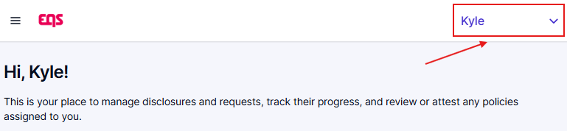
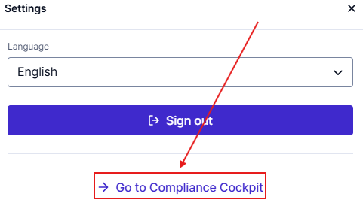
- Note - if a disclosure requires your action, you will receive a notification email with a clickable link to the direct item in the Compliance Cockpit.
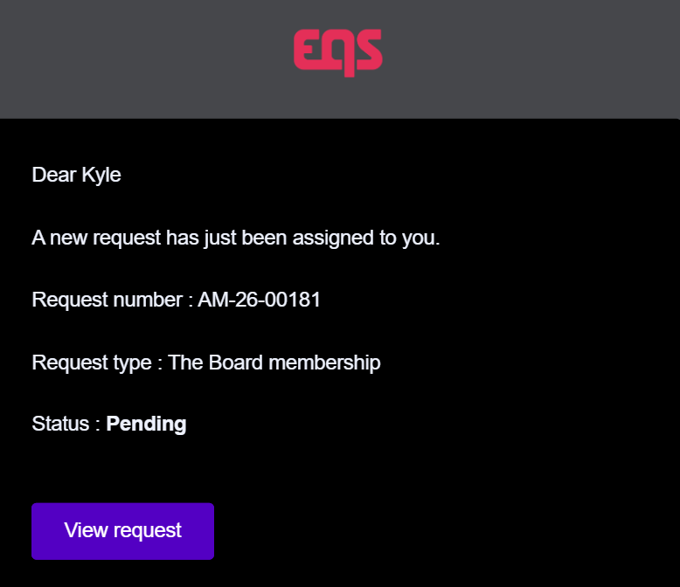

Disclosures overview and export disclosures
- After opening the Approvals module in Compliance Cockpit, click on the Disclosures tab to see all disclosures that you have access to.
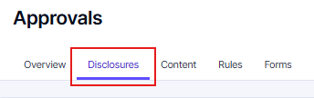
Important: Irrespective of your permissions, you will never be able to see your own disclosures in the disclosures tab. This restriction is in place to prevent you from approving your own disclosures.
- The list of disclosures can be filtered based on several attributes. Click ‘Filter’ and select all relevant filters. It is possible to combine multiple filters. The "Assigned to → Pending my approval" filter can be particularly useful if you are often named in the second review stage in a workflow.
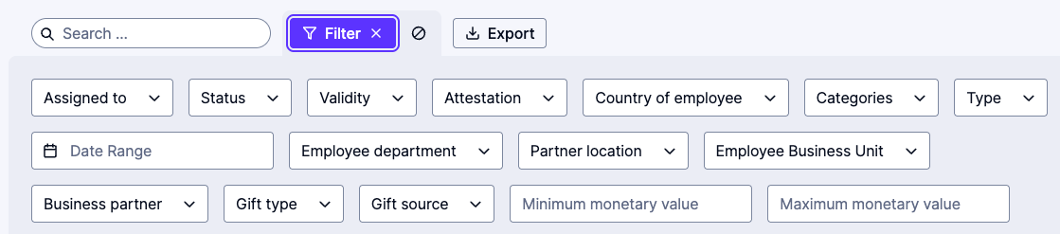

Receive & manage disclosures
- When an employee submits a disclosure that is assigned to you, you will receive an automated email notification that a disclosure has been assigned to you. You can click the link within that email to directly access the new disclosure.
- You will also receive a weekly summary of disclosures pending your action. Clicking the link will take you to the disclosure overview screen in Approvals.
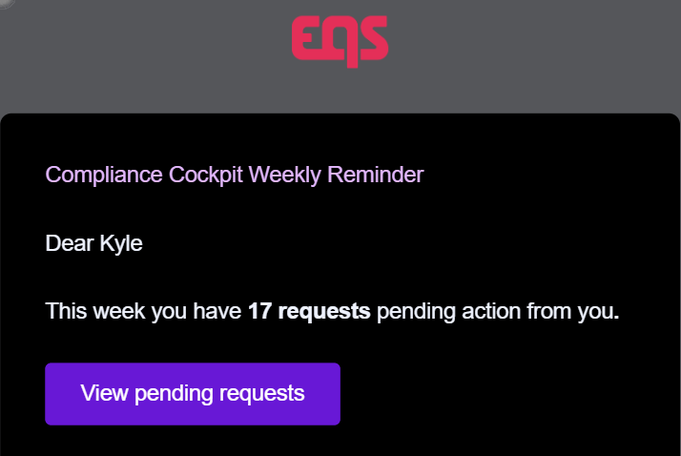

What's in a disclosure
- Click the ‘disclosure tile’ to open the disclosure details.
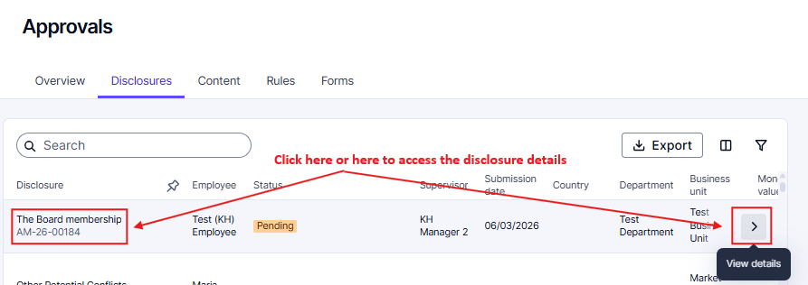
The disclosure detail page shows information about the disclosure and the employee who submitted it, including
- Disclosure type and ID
- Employee: Employee name and country
- Additional details: Date, disclosure type
- Supervisor: Name and email address of the employee's supervisor for quick contact
- Business partner: Business partner details (if applicable)
- Disclosure outcome (updated when a final decision has been made)
- Detailed form with the employee responses
- If an employee updates their disclosure after the submission, the changes compared to the previous version are highlighted. Enable the toggle ‘Show updates only’ to filter for any disclosure responses that have been updated since their previous submission. Additionally, whenever a disclosure is updated by the employee, the previous version will automatically be deactivated and linked. You can access this linked disclosure on the right side.
Note - Linked disclosures include other disclosures in this same category (gifts, conflict of interest or invitation).
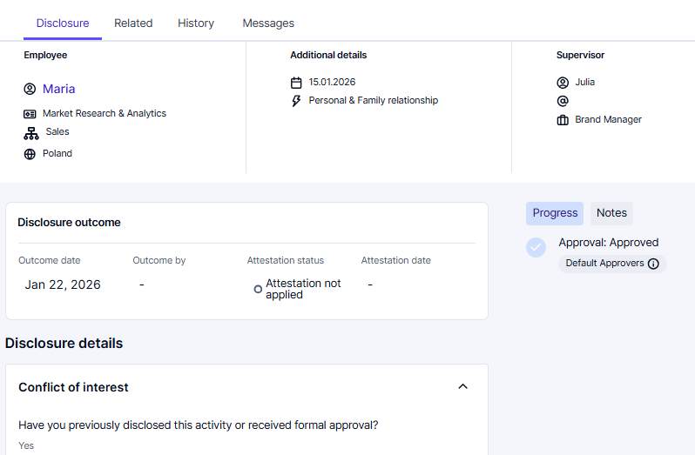
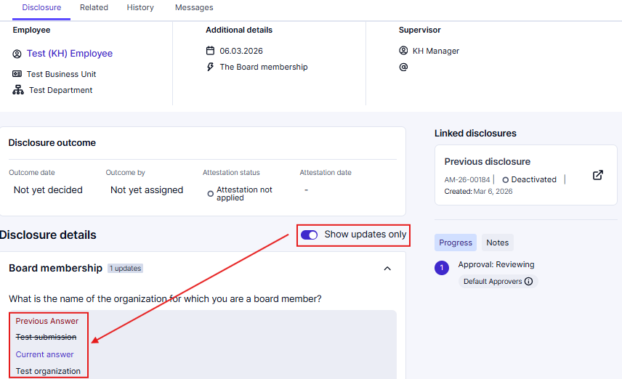
- By clicking on ‘Related’, you can see disclosures from other categories that have been submitted by the same employee. Clicking on the tile of the disclosure from this page will open the detail view.
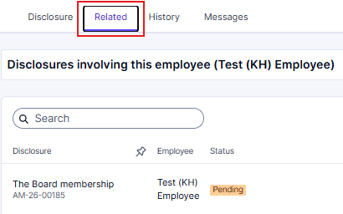
- Clicking on ‘Messages’ will open the messaging function. This allows you to exchange messages with the submitter. The submitter will receive an email notification directing them to the Messages tab.
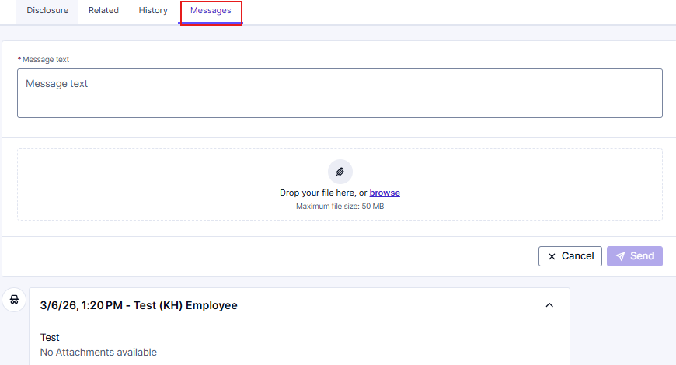
- You can enter a message and attach files to send to the employee.

Manage disclosure access
Access to a disclosure is mostly managed automatically based on a user’s permissions and the automated assignment rules set up in the Rule Engine. However, in some scenarios you might want to grant or remove access to an additional user. You can adjust access by clicking ‘More actions’ and selecting ‘Manage access.’
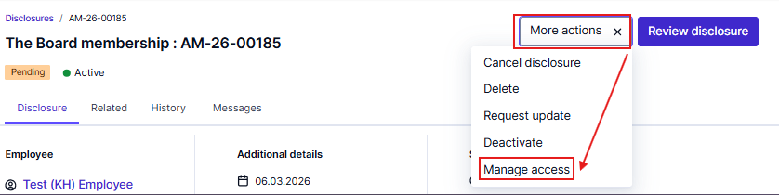
Important: The manage case access functionality is intended for one-off disclosures and exceptions.
Similarly, when a supervisor of an employee changes, this allows the new supervisor to see all pending and new disclosures immediately, if the supervisor is set in the approver group.
The following modal summarizes current user and user group access. Individual access shows individual users who have been manually granted access to this disclosure. Group access reflects the approver group(s) who have been added to this disclosure based on the automated rules engine or added via manual forwarding by approvers. Note, only users with permission to access Approvals can be added or removed.
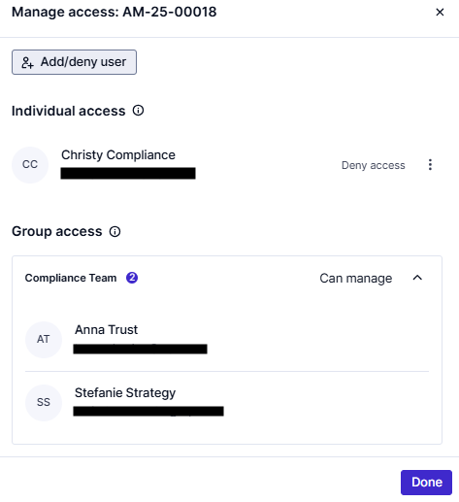
- Click ‘Add/deny user’ to change access for one specific user.
- Click ‘Select user’ and start typing the user’s name to search the list of users. Only users with permission to access Approvals will be listed here. Click on the user for whom you want to change access for this disclosure.
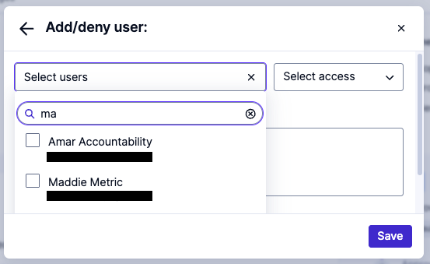
- Select how you want to update access for this user.
- Can view: This user will be able to access the disclosure, but will not be able to edit anything, even if their permissions would normally allow them to.
- Can manage: This user will be able to access the disclosure and edit it (approve, acknowledge, approve with conditions, decline, reopen, send messages). Also, this user will receive email notifications about status updates regarding this disclosure.
- Deny access: This person will no longer have access to this disclosure even if they are part of the assigned Approver Group or have permission to access all disclosures.
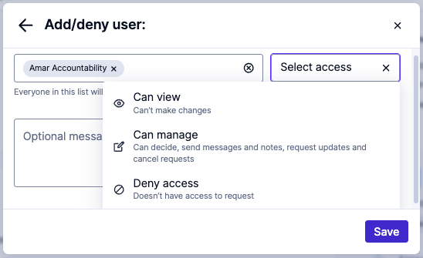

- Add an optional Message detailing why access was changed. Click ‘Save.’ The system will show a summary of the changes, detailing the consequences of your changes. Confirm again.
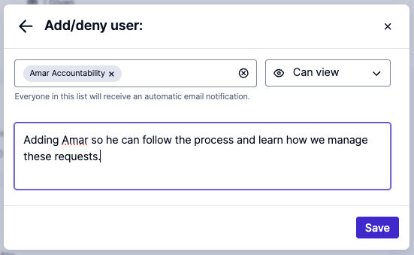
An email will be sent to the user(s) that were added. For example:
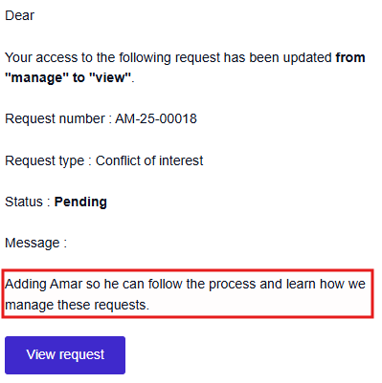
- The overview modal shows the changed access. Click the ‘ellipses’ to edit the exception and select a different option or reset the access to the default state, based on user permissions.
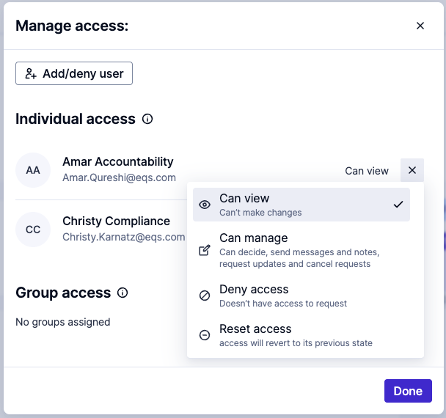

Review disclosures and decisions
- After reviewing the disclosure, click the ‘Review Disclosure’ button to document the decision.
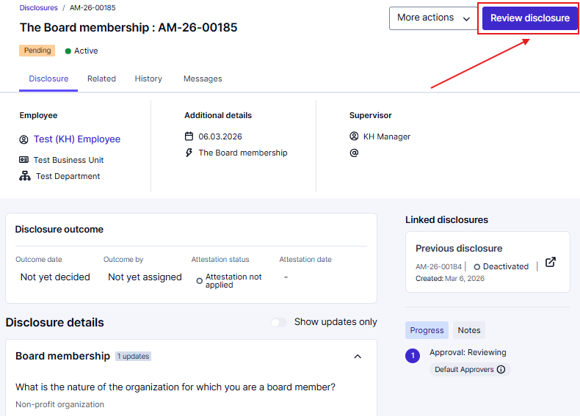
- Select the decision:
- Acknowledge: Log disclosure without formal approval. Recommended for conflict of interest (COI) cases with low risk (e.g., minor personal connection).
- Approve with conditions: Log disclosure with safeguards. Recommended for disclosures needing mitigation (e.g., donate gift, avoid selection involvement).
- Approve: Formally approve the disclosures. Recommended for gifts/invitations when the company accepts responsibility (e.g., business dinner, client event).
- Reject: Deny the disclosure. Recommended for high-risk or policy-violating cases (e.g., luxury gift, unmanaged COI).
- Select ‘Require employee to attest to outcome’ if you require the employee to confirm the outcome – the employee will receive an email that additional action must be taken.
- Use the optional Decision message field to clarify any reasons, requirements and conditions. This is the "outcome" your employee will see. Attach any relevant files.
- By default, the decision message is only documented for other Approvers. Tick the box ‘Share with employee’ to share the message with the employee too.
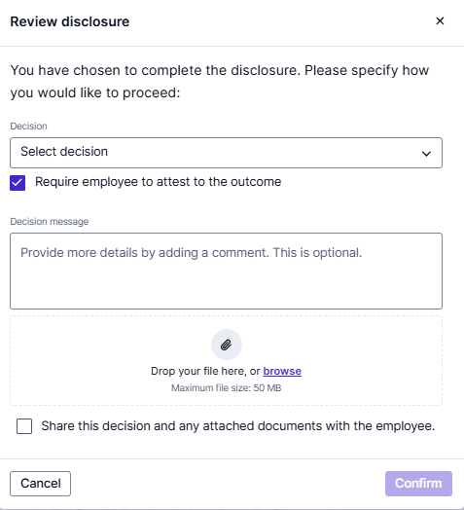
- If multi-stage approval stages are configured, the progress tracker will show all Approvals steps. Your decision will be documented for your stage, and the disclosure will automatically be forwarded to the next Approver stage. Once the last Approval stage has been completed or if any Approver rejected the disclosure, the status will be updated and the employee will be informed.
- Note: At any stage of the review cycle, if the reviewer rejects the disclosure, that becomes the final decision. This means that the disclosure will not progress to the next stage – the workflow will be halted.
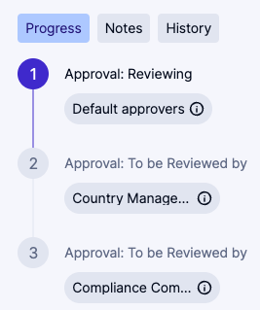
- After a final decision has been made, the status of the disclosure will be updated. Additionally, the progress tracker will be updated.
- The disclosure outcome will document when and by whom the decision was made. It also shows the attestation status and the attestation date (as soon as the employee completes the attestation).
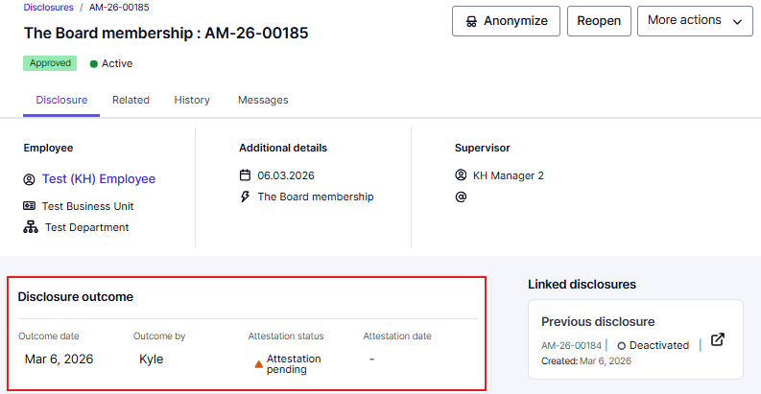
- For further details, switch to the ‘History’ view. This view includes a detailed history of changes for this disclosure, including the involved users and timestamps.
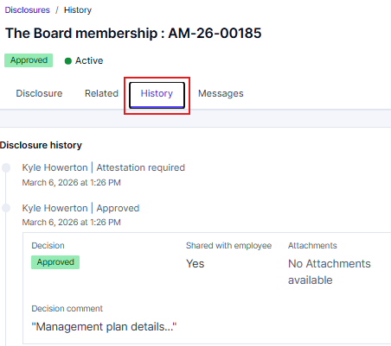
- You can use the ‘Notes’ functionality to document the decision process and add information for other Approvers. These notes will not be visible for the employee.
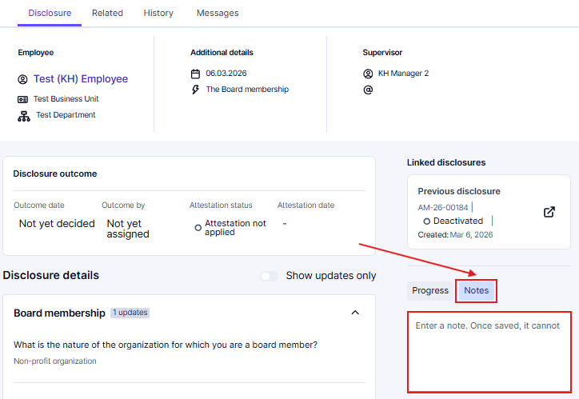
- The employee will receive an email notification when the status has been updated.
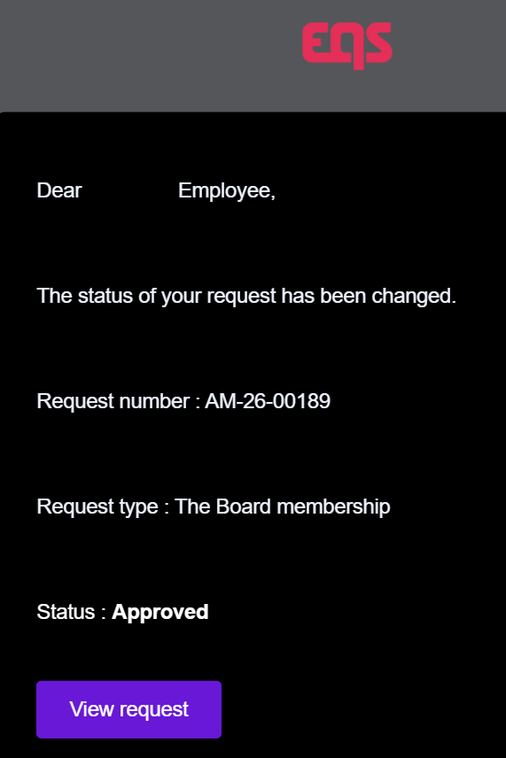

Acknowledge/accept and forward
- Alternative to acknowledging or accepting a disclosure, you can click ‘Acknowledge and forward’ or ‘Accept and forward.’ This will send the disclosure for additional approval for review before completion. Note, you only have this option if you are the approver in the very last review stage.
- This will document your decision but forward the disclosure to other Approvers for further review and approval. The employee will not be notified about this decision.
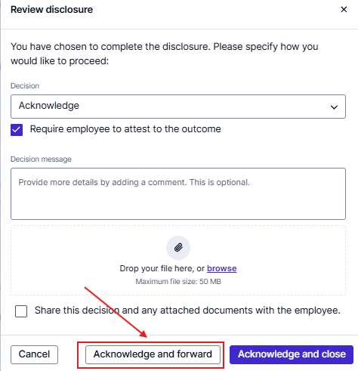
- In the following pop-up, you can select Approver Groups or individual users who will receive this disclosure for further review. In the users dropdown, you will only see users with the permission to approve disclosures as a second instance.
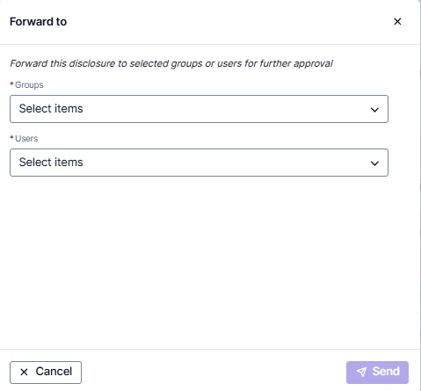
- The additional approver(s) will receive an email notification informing them about the disclosure that has been handed over to them.
- The disclosure will remain in status ‘Pending,’ but the progress tracker will reflect your preliminary decision.
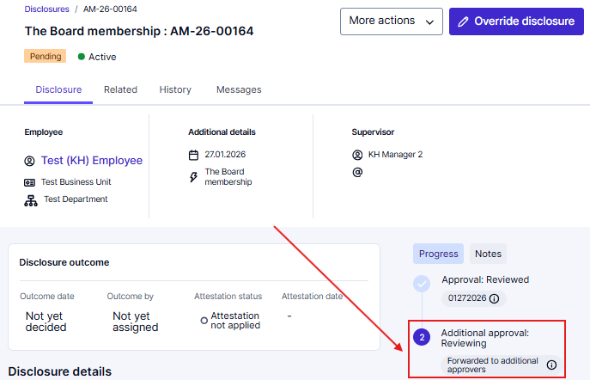
- The employee will only be informed about the final decision to avoid confusion.

Reopen disclosures
- If the decision needs to be changed due to updated information, a disclosure can be reopened by a user with the appropriate permission.
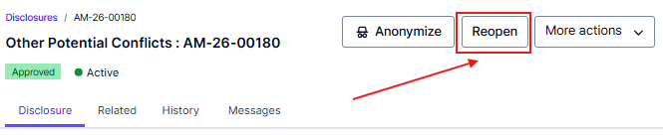
- Add an optional comment to explain why the disclosure must be reopened. Attach any required files.
- Check the ‘Share with employee’ checkbox if this comment shall be shared with the employee.
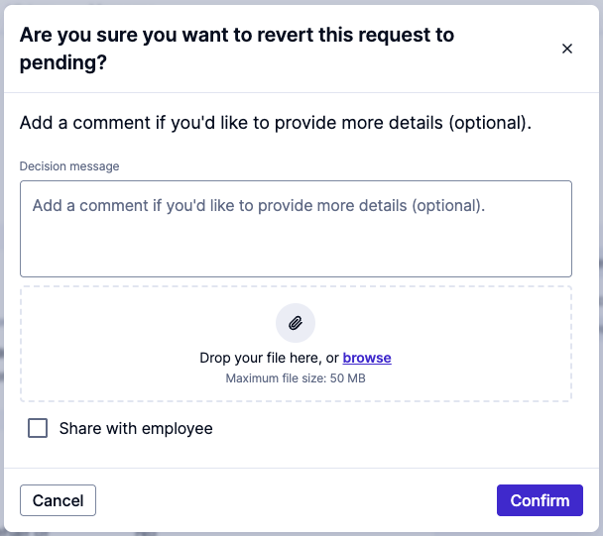
- The disclosure will be moved back to the status pending, and the employee will be notified that they need to resubmit. The history of the disclosure will reflect this change. Once the disclosure is resubmitted, the history will reflect this change. The disclosure will require another review cycle starting at the beginning of the original assigned workflow.
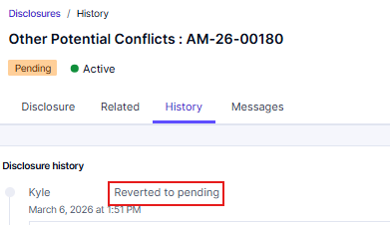
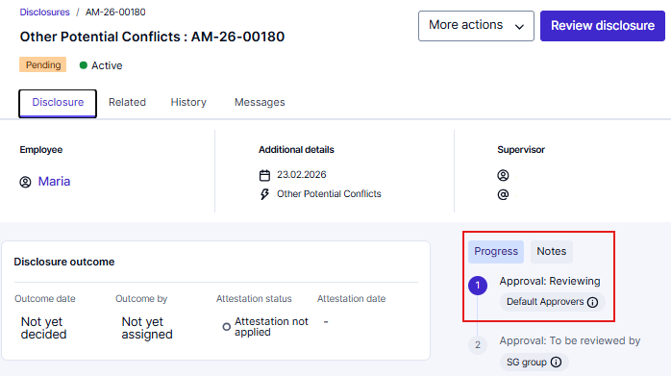

Override disclosures
- The ‘override disclosure’ button will only be visible if you have access to a pending disclosure but are not part of the assigned Approvers. This can happen if you have permission to access all disclosures, but you are not part of the currently assigned Approver Group.
- Note - This is an escalated permission that only select Approvers will have.
- By clicking ‘Override disclosure’, you can deviate from the configured workflow even if you are not the assigned approver.
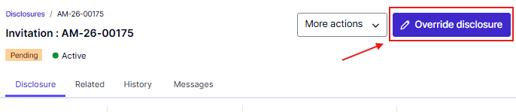

Further actions
There are a few additional actions you can take on a disclosure:
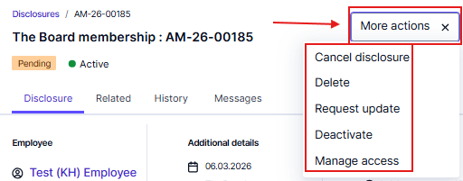
- Cancel disclosure: If the disclosure is out of scope, or if there is any other reason not to process this disclosure, you can cancel it. This will update the status to Cancelled in Approvals and Integrity Hub. The employee will receive an email notification about the cancellation.
- Delete: If you wish to remove a disclosure from Approvals, you can delete disclosures. Only users with permission to delete disclosures will see this button. Deleting a disclosure permanently removes it from Approvals and Integrity Hub.
- Disclosure update: Usually, an employee cannot edit the information provided for their disclosure after it has been submitted. If you would like to enable them to change/update/add information, you can request an Update. Enter an optional message for the employee explaining why an update is required. They will receive an email notification about the change. The disclosure will be marked with the status Update requested until the employee updates it. Then it will be set back to ‘Pending’ status.
- Note - Any decisions that were previously made by reviewers will remain unchanged, but the remaining reviewers will get notified to complete their review.
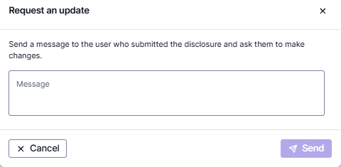
- Note - When the employee receives the email notification and clicks through to the disclosure that shows ‘Update Requested,’ they must click on the purple button in the top right corner to open the disclosure for editing.
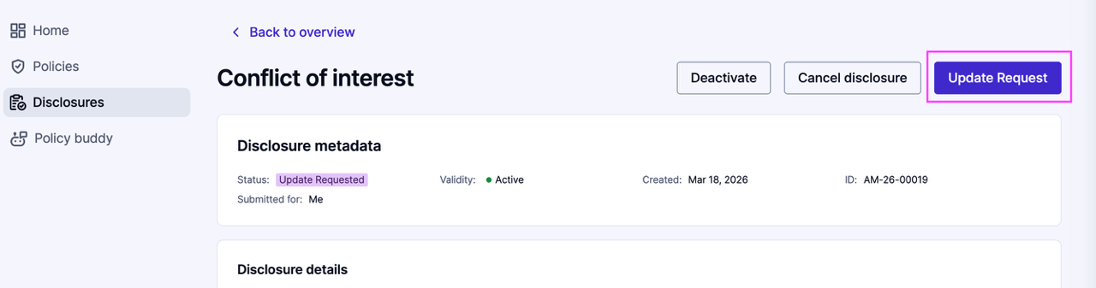
- Deactivate: Employees and Approvers can deactivate a disclosure to mark that it is no longer relevant. You will be asked to specify the reason for deactivating this disclosure.
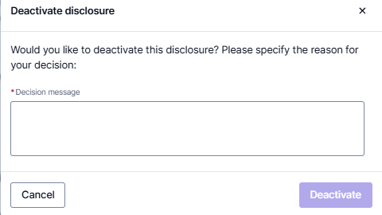
- Manage access: This allows you to share the disclosure with additional users (read only or read and write) as well as to remove access for selected users. Detailed guidance can be found above in this guide and in the article ‘Manage Disclosure access’)

Anonymization of disclosures
Anonymization of disclosures allows compliance teams to manually remove sensitive personal data. Use anonymization to remove personal data when required by your region’s data protection regulations.
- Open the relevant disclosures where a decision (Acknowledged, Reject, etc.) has already been made. Note, the disclosure must be closed for the ‘Anonymize’ button to appear).
- Click on the ‘Anonymize’ button in the top-right of the disclosure to open a new page with options to anonymize data in the details, notes, messages, or decisions of the disclosure.
- To anonymize data, double-click on the text you want to anonymize.
- The pending anonymized data will now show with a strikethrough.
- Confirm the action by clicking ‘Anonymize’ in the bottom-right of your screen.
- This will present a pop-up—click ‘Confirm final anonymization’ after checking the box to save the anonymization.
- The anonymized data will be permanently deleted in the Integrity Hub, Approvals module, data exports, and cannot be restored.
- To anonymize attachments, click the ‘bin’ icon 🗑️ on attachments to mark them for permanent deletion instead of double-clicking.
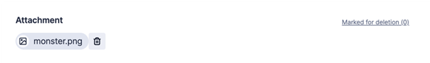
Important: A disclosure may have no anonymizable data. For example, you cannot anonymize a “Yes” or “No” in a dropdown, as this information does not allow for personal data or personal identifiable information to be entered. Therefore, no information can be removed.

