



Employee user guide - approvals
This user guide steps through how to submit a disclosure in Integrity Hub

Table of Contents
1. Introduction 2
2. To Submit a disclosure 2
2.1. Creating a new disclosure 3
3. Saving a disclosure as a draft 5
4. Making changes to a request 6
5. Communicating with an approver 7
6. Update requested status 8
7. To deactivate, reactivate, or cancel a disclosure 10
7.1. Deactivate a disclosure 10
7.2. Reactivate a disclosure 11
7.3. Cancel a disclosure 12
8. After a disclosure is reviewed 13
9. Attestations 14
9.1. Attest to a disclosure 14

Introduction
The Integrity Hub enables employees to submit disclosures such as gifts, invitations, and conflicts of interest through a user-friendly portal. Submissions are automatically routed to the appropriate team for review.

To Submit a disclosure
- Log in to Integrity Hub.
- Note – This guide can be edited. The link to your specific Integrity Hub environment can be added here.
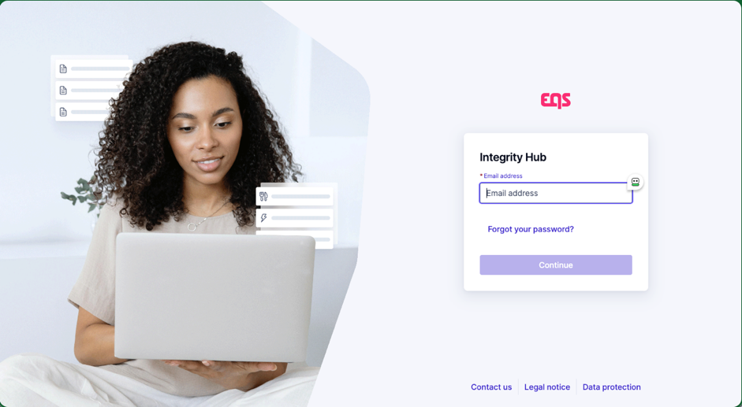
- You will land on the Integrity Hub Home screen.
- To create new disclosure from the Home screen, click the ‘+ Create disclosure‘ button on the right-hand side of the screen.
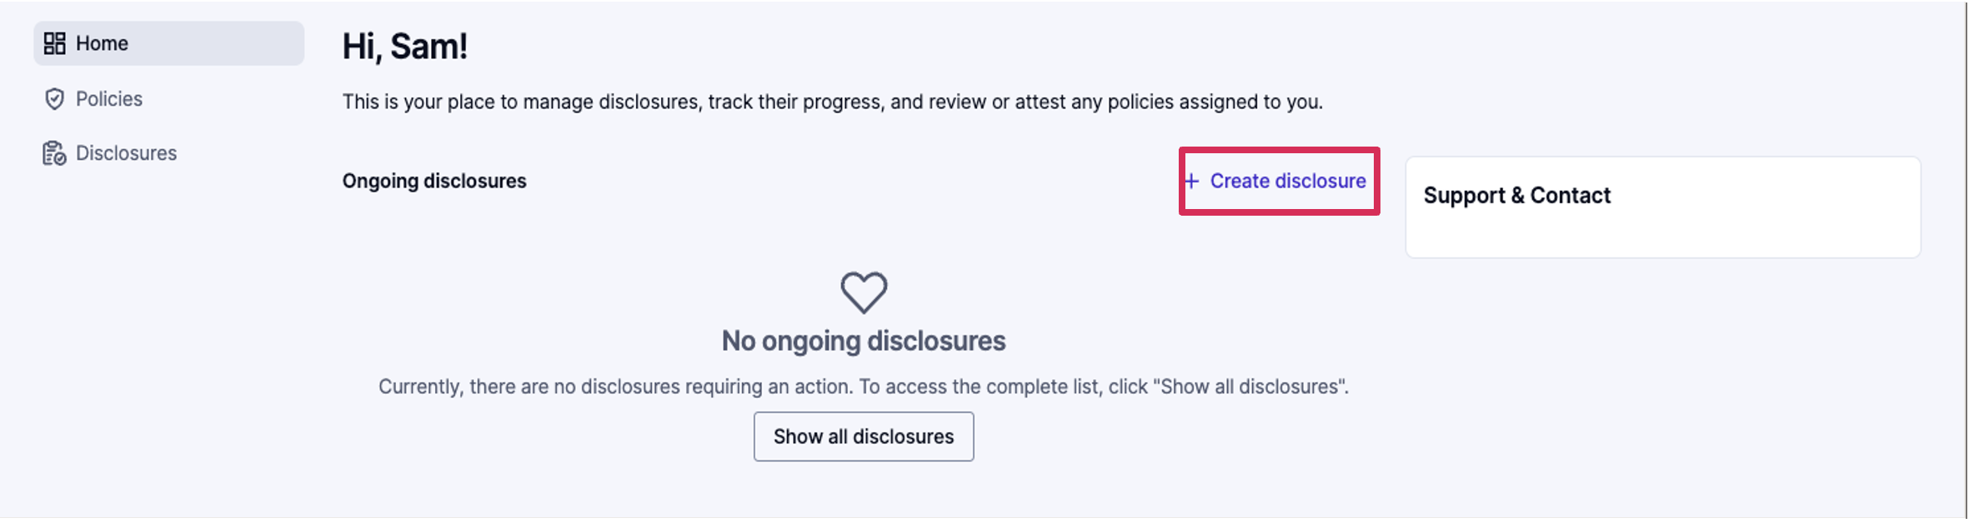

Creating a new disclosure
- You can also create a new disclosure by clicking ‘Disclosures’ in the menu on the left, then clicking ‘+ Create disclosure’ button.
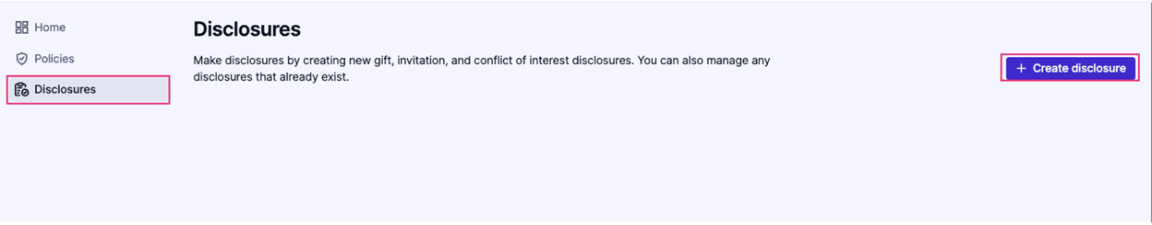
- Choose the appropriate type of disclosure from the list, using the descriptions as a guide.
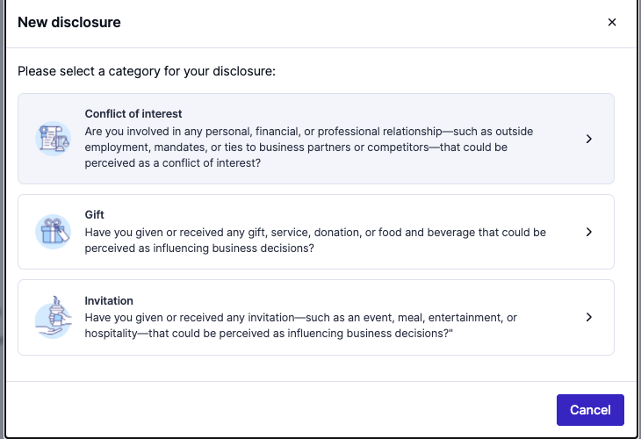
- Fill out the questions displayed in the request form, then click the ‘Continue’ button. The ›‘Continue’ button will remain disabled until all required questions are answered.
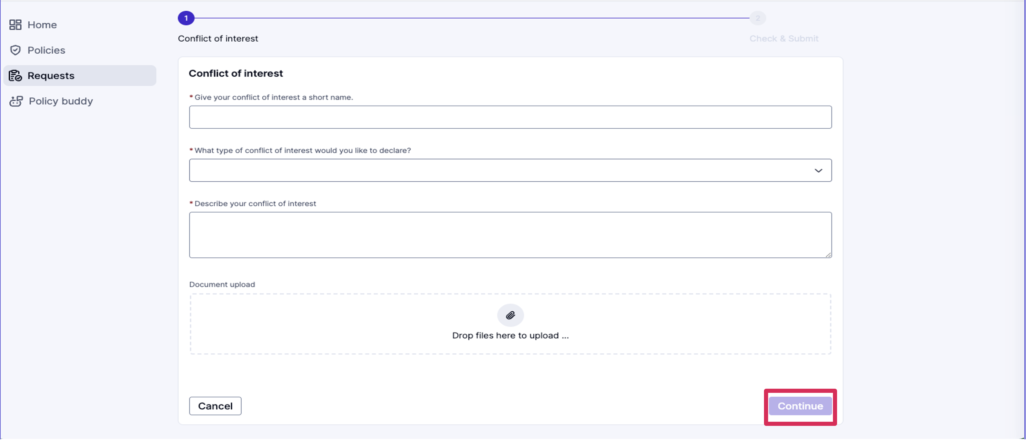
- After clicking the ‘Continue’ button, you can review your answers. If you would like to make any adjustments, click ‘Previous,’ which will take you to the previous screen and allow you to update your responses.
- Click the ‘Send disclosure’ button once you have reviewed your responses and are ready to submit.
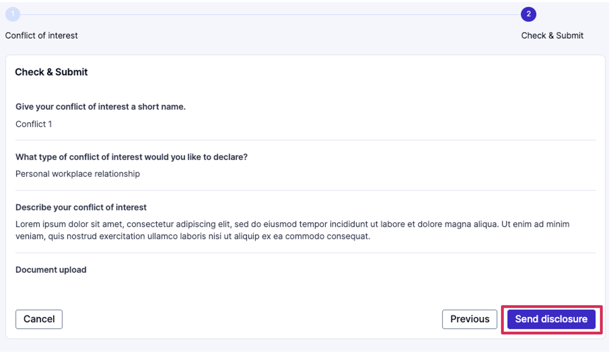
- Your disclosure will show in a ‘Pending review’ status upon submission. Once your disclosure has been reviewed, the status will change to reflect the decision (‘acknowledged,’ ‘approved,’ or ‘rejected’).
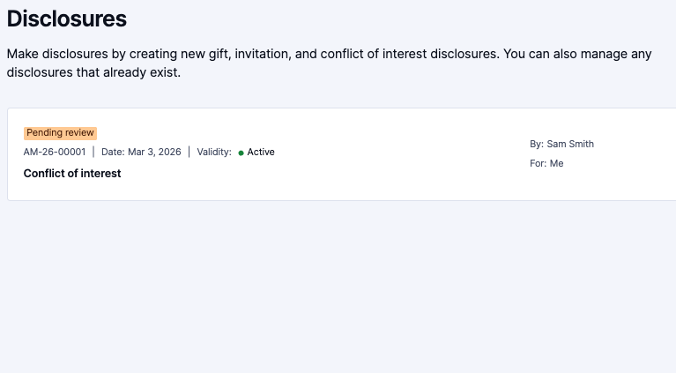

Saving a disclosure as a draft
The disclosure form can be saved as a draft version so that you can continue your responses at a later time. When in a disclosure form, click the ‘Cancel’ button at the bottom left-hand side of the screen, and you will be prompted to choose from the following options:
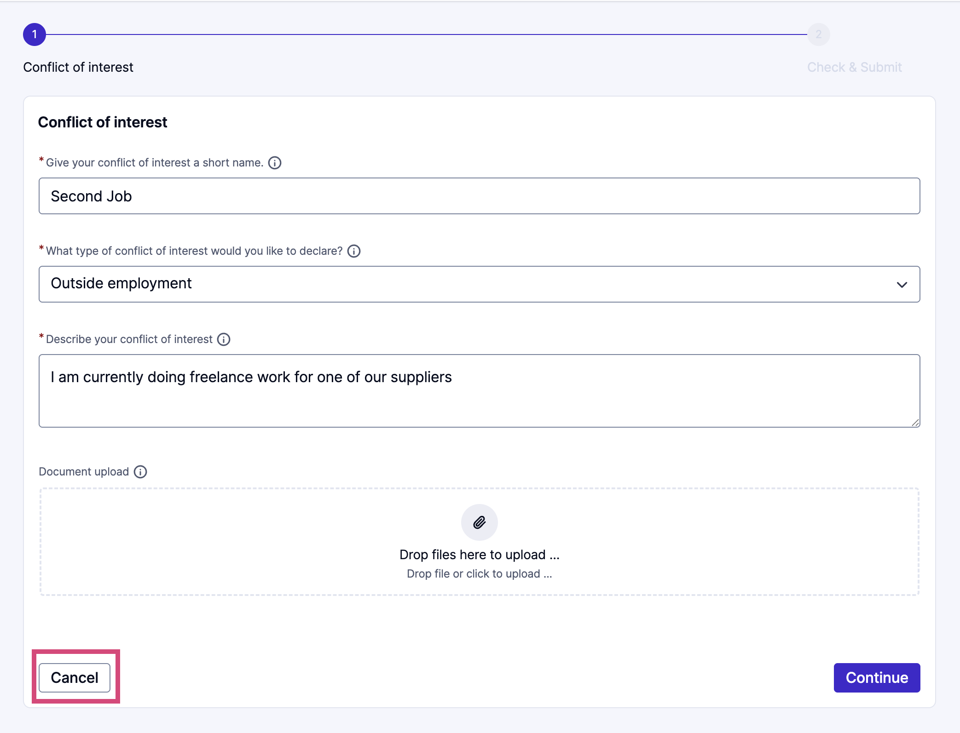
- ‘Back to form’
  - This will close the pop-up and let you finish answering the form questions
- ‘Save as a draft & leave’
  - The draft will be saved and can be accessed again on the Disclosures start screen
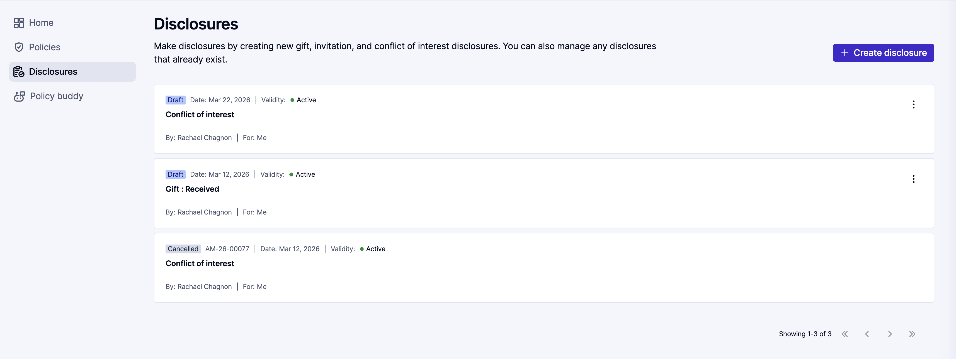
- ‘Leave without saving’
- Choose this option if you originally selected the wrong disclosure category. You can select a new category and submit the correct disclosure form.
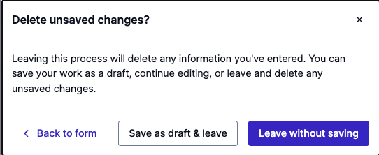

Making changes to a request
Providing more information while a disclosure is ‘Pending review’
- Navigate to the Integrity Hub.
- Locate the disclosure on the Home screen and click the ‘View’ button. You can also click ‘Disclosures’ in the menu on the left to see your list of submitted disclosures. Locate the disclosure and click it.
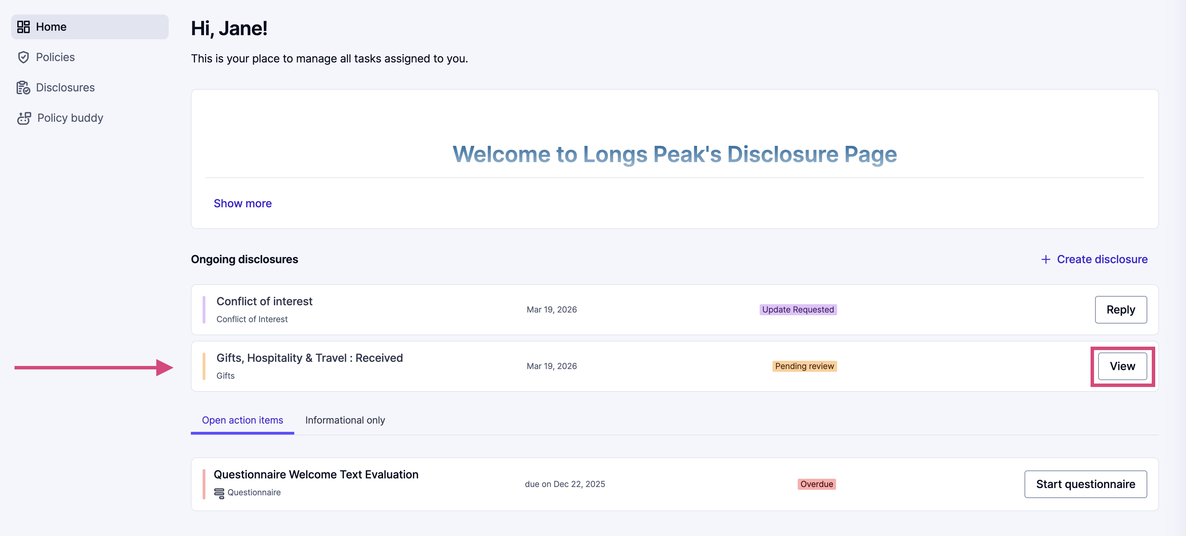
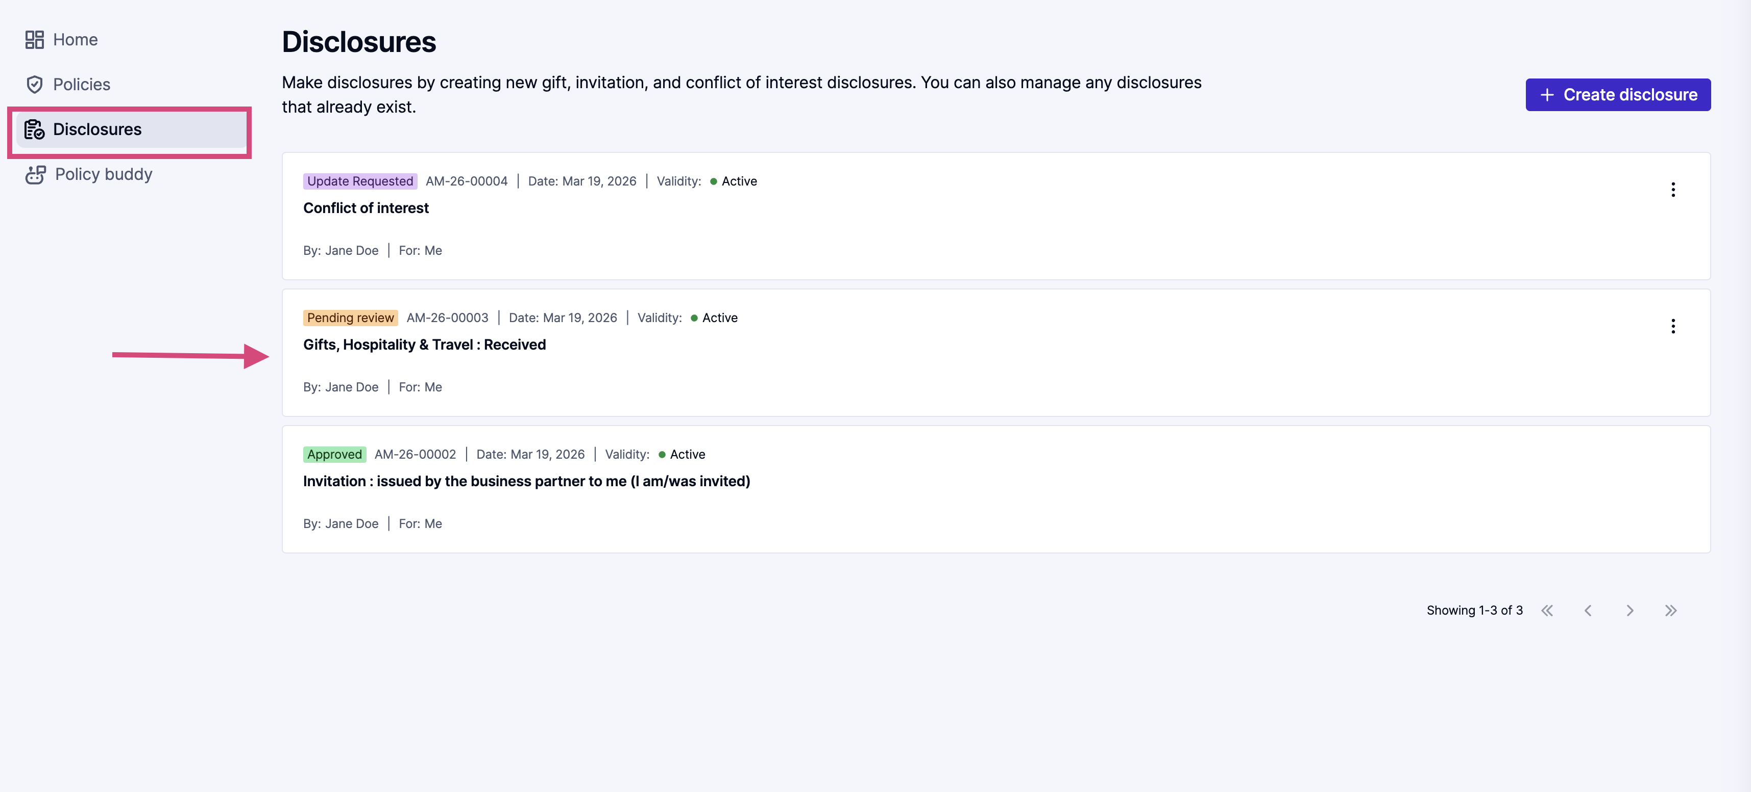
- Add any information or attachments to the Messages section of the disclosure and click the ‘Submit’ button.
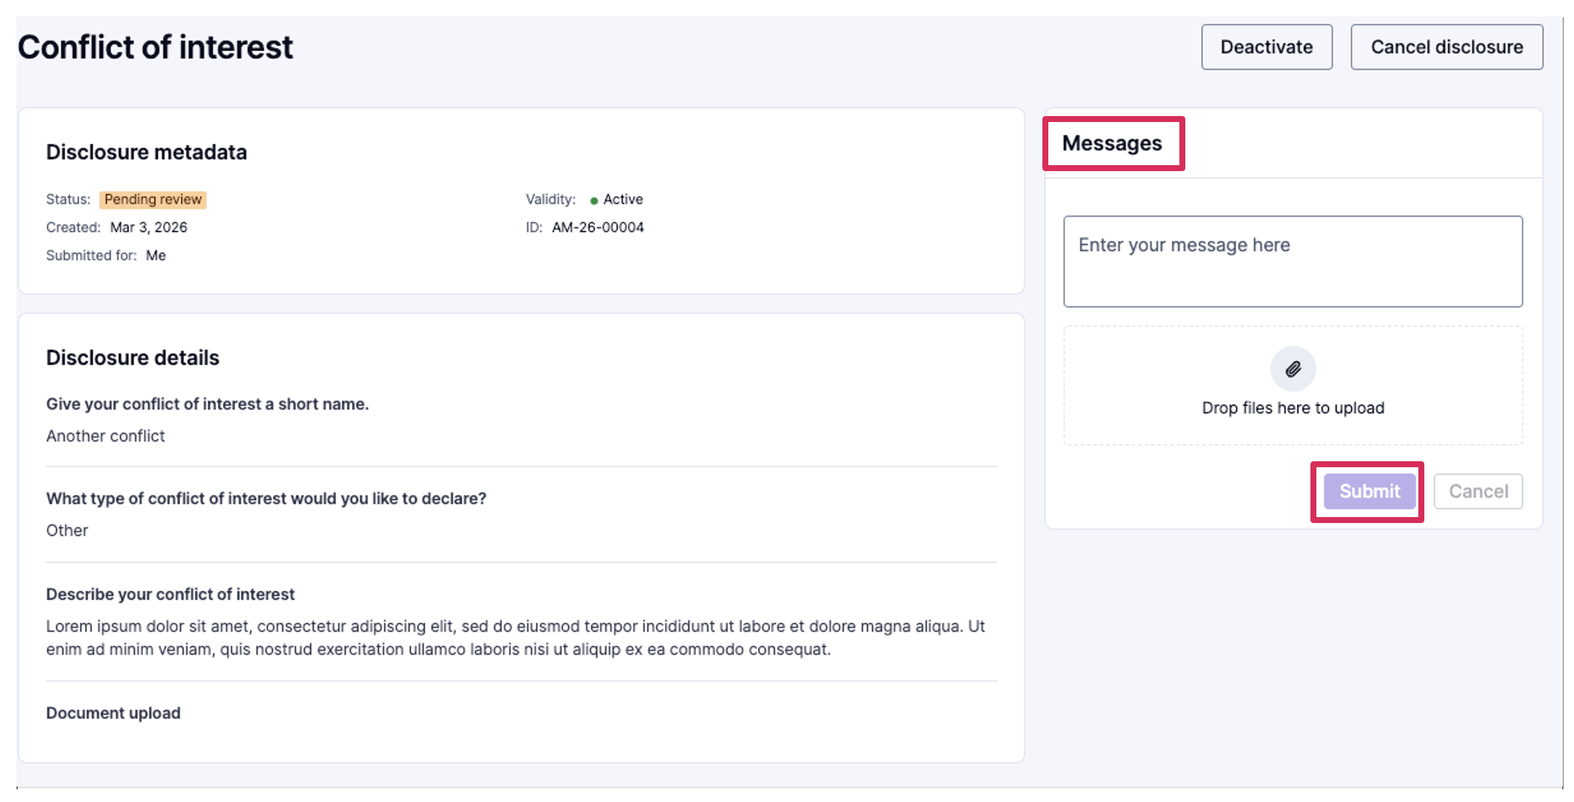
- Note - Once a disclosure is in a ‘Pending review’ status, you cannot update question responses unless an approver prompts you to do so; the status of the disclosure will change to ‘Update requested’ when this occurs.

Communicating with an approver
If the approver sends a message, you will receive an email notification.
- Click the link in the email to be directed to your disclosure message. You can locate and respond to the message in the disclosure under Messages. Make sure to click the ‘Submit’ button to send your response.
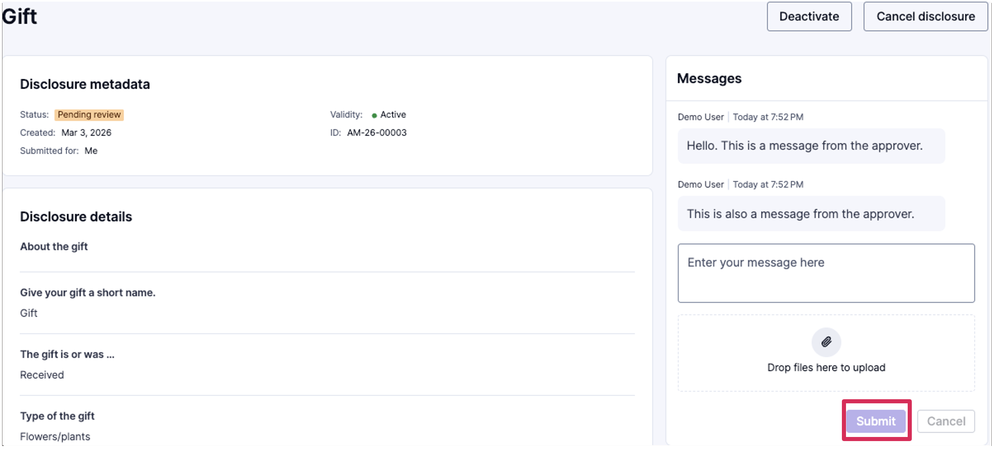

Update requested status
Sometimes an approver may require an update to your submitted disclosure, for example if you entered a date where a dollar amount was expected. When an update is requested, you will get an email notification. Here are the full steps to make the necessary update:
- You’ll receive an email notification like the one below.
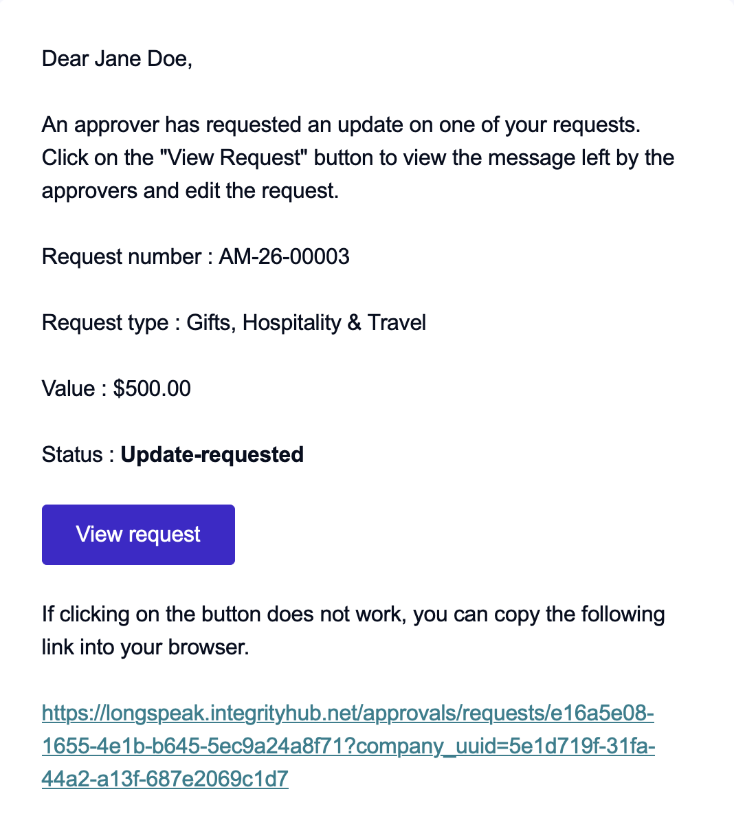
- Click through the email to log into Integrity Hub. You’ll land straight on your submitted disclosure
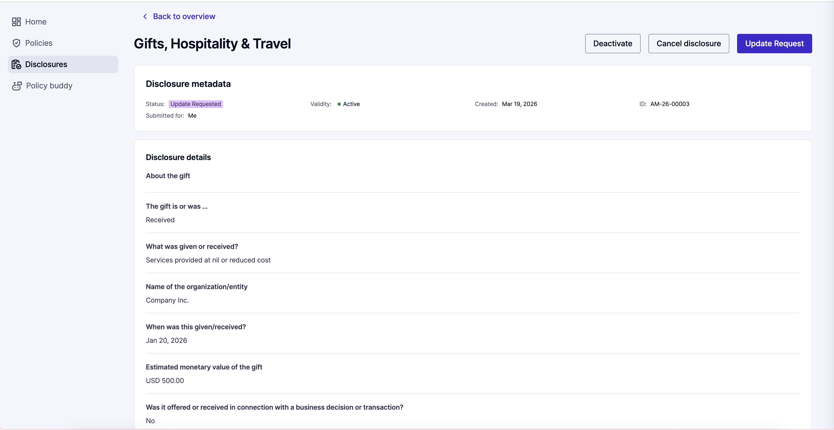
- Scroll to find the Messages section, where the latest message will contain details about the updates that are needed.
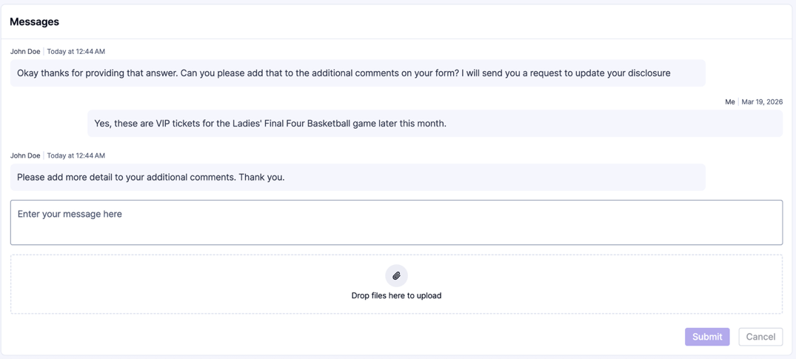
- Click the purple ‘Update Request’ button at the top right of the page to open up the disclosure for edits.
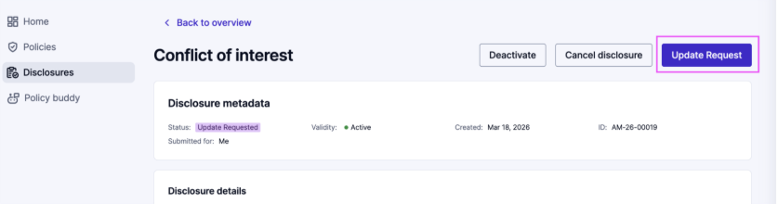
- Click through the form to make your updates and then press ‘Continue’
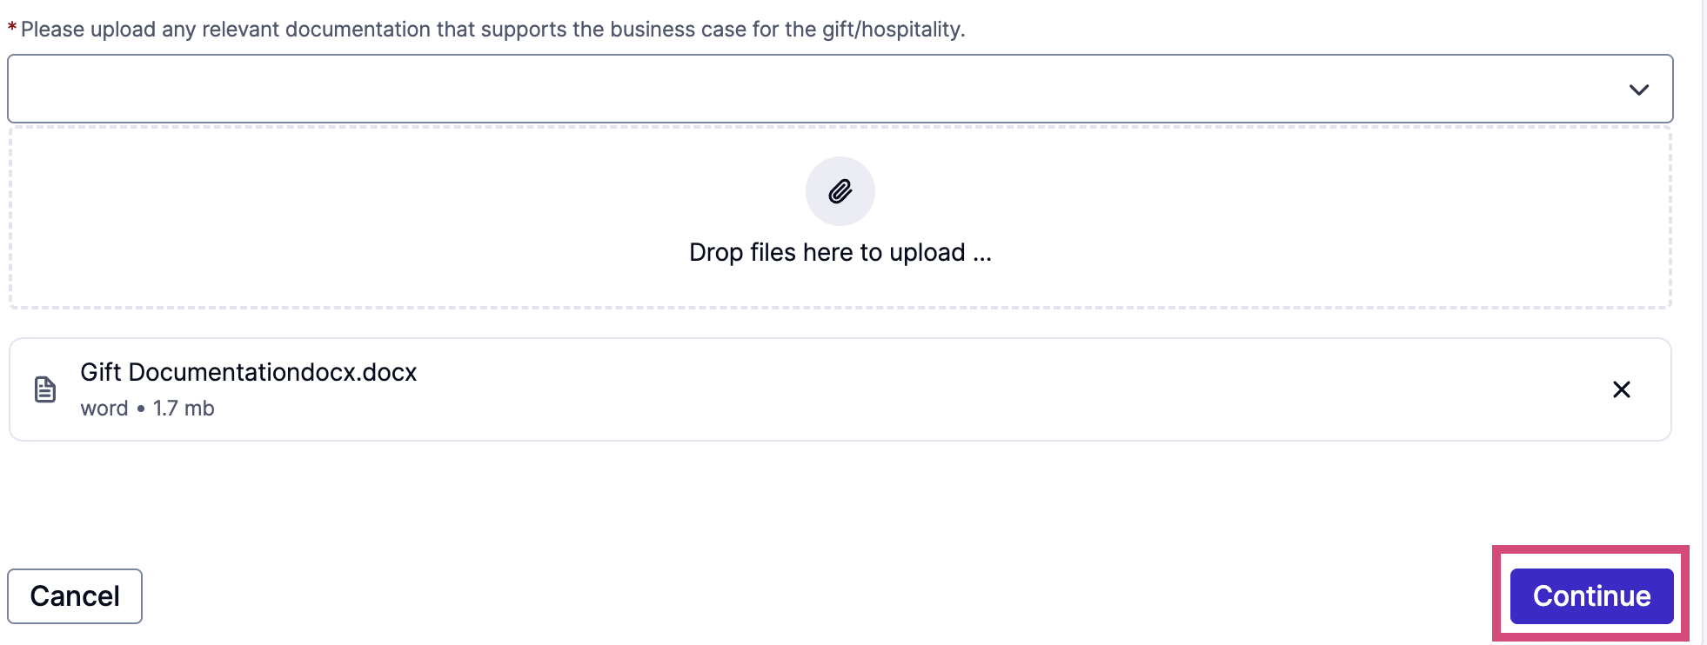
- Click ‘Send Disclosure’ when ready to submit.
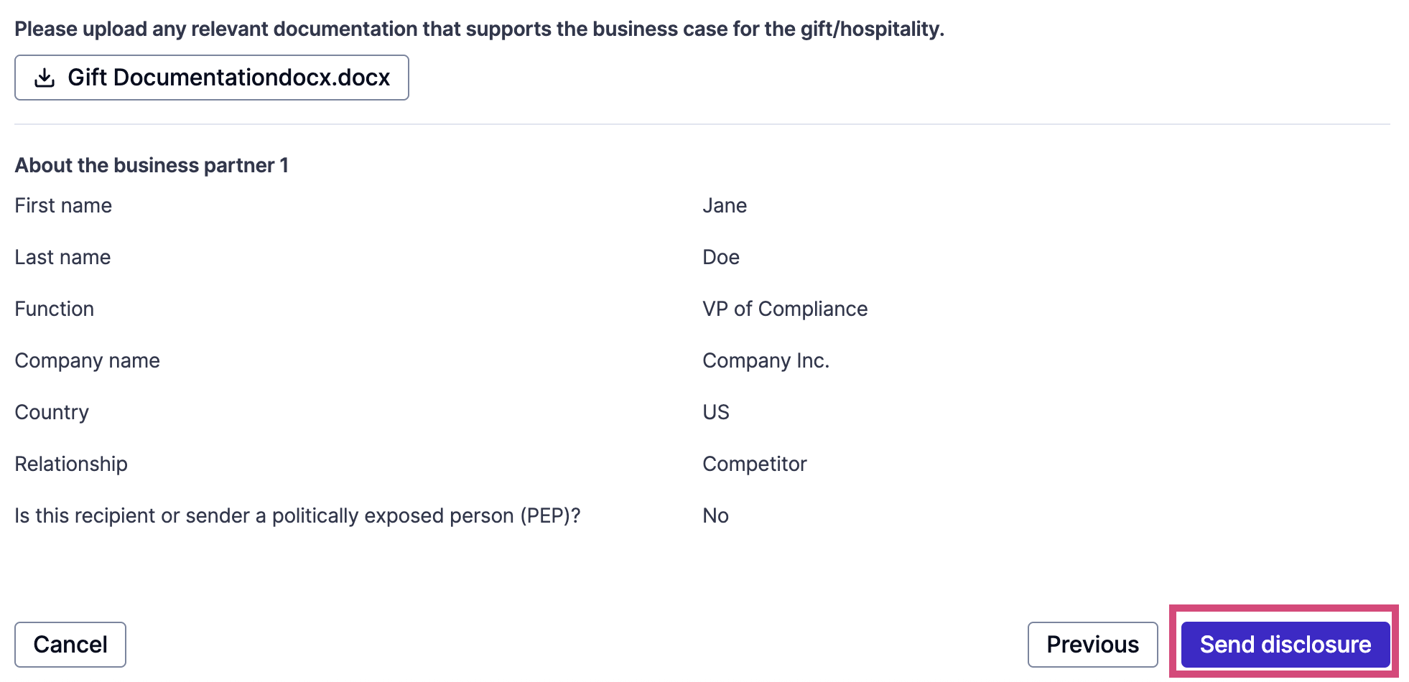
- If you need any clarification from the approver before making your update, click ‘Cancel’ to navigate back to the disclosure overview, and send a message asking for clarification. You will get an email notification when they send a response.
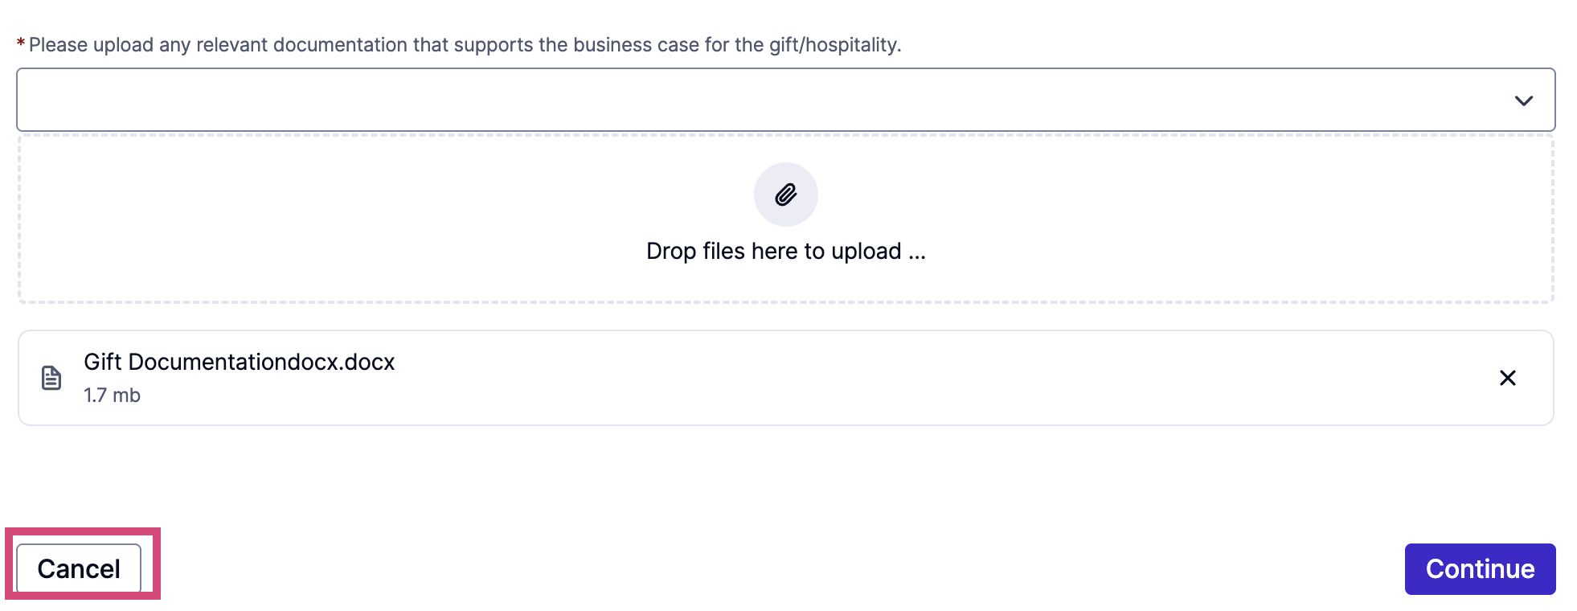

To deactivate, reactivate, or cancel a disclosure
You may find that you need to deactivate, cancel, or reactivate a disclosure.

Deactivate a disclosure
Deactivating a disclosure indicates that a disclosure is no longer relevant, for example if you have left a second job that you had previously disclosed.
- Find the disclosure you would like to deactivate.
- Open the disclosure.
- Click the ‘Deactivate’ button.
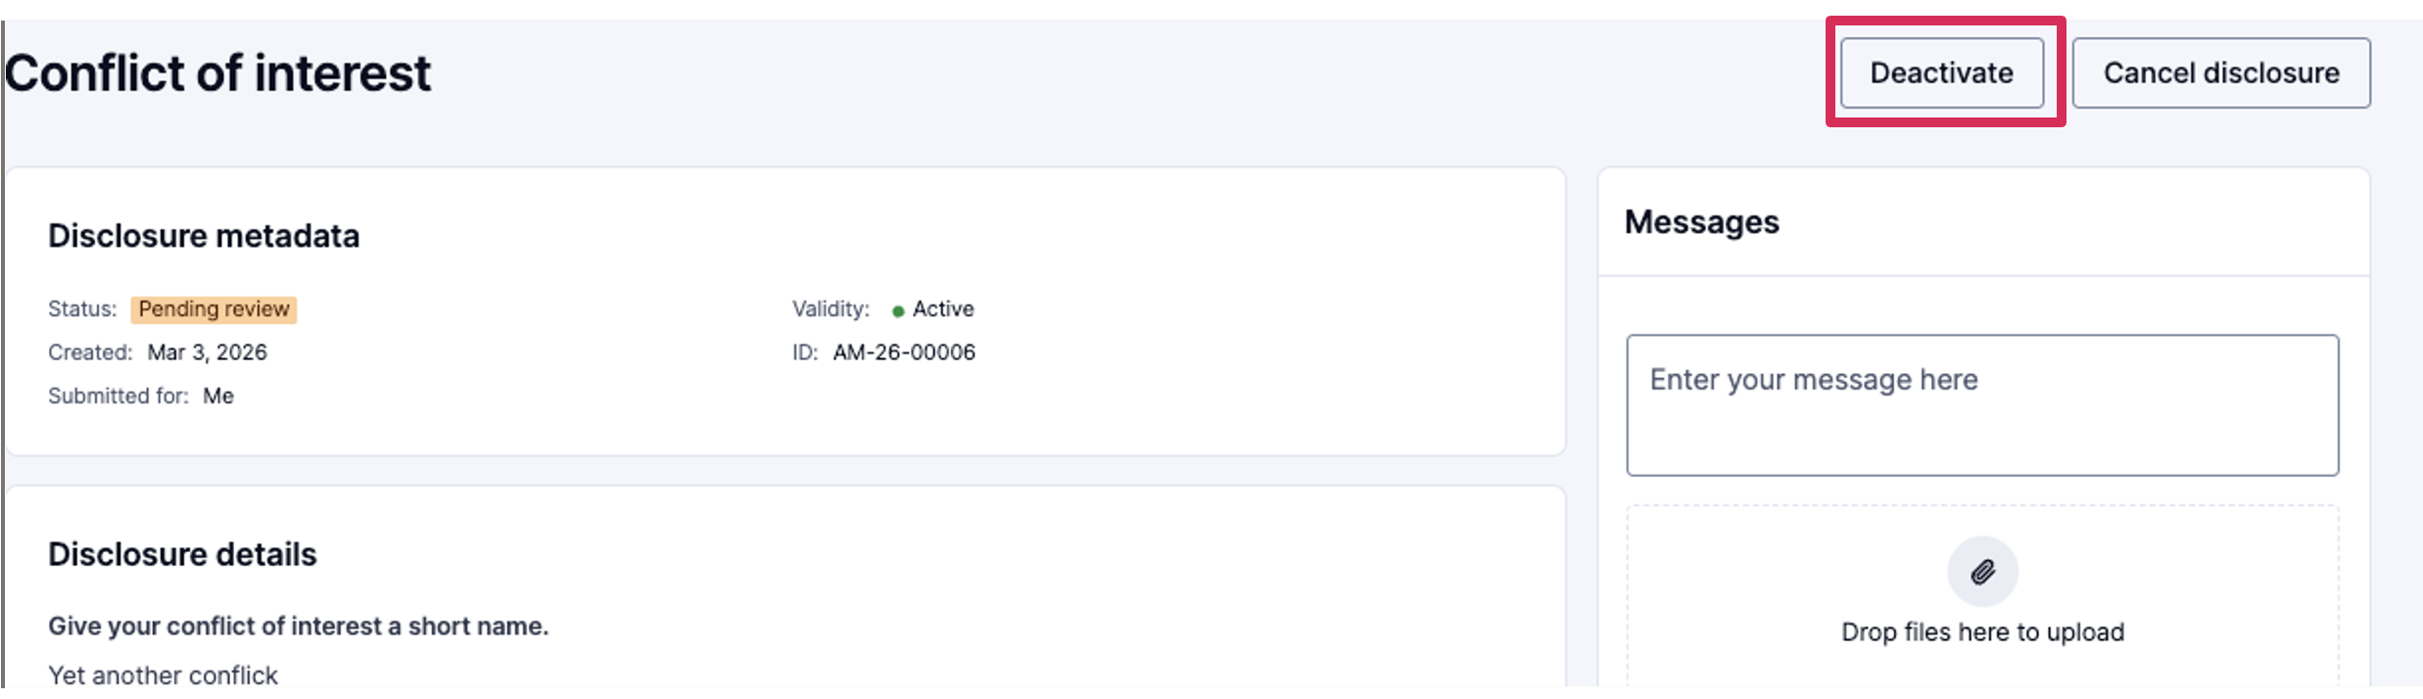
- When you Deactivate a disclosure, you will need to provide a reason for the deactivation and click ‘Confirm.’
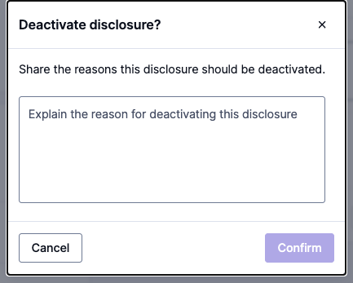
- The disclosure will then show as inactive, but with a ‘Pending review’ status. While inactive is not the status of the disclosure, it is denoted in the validity.
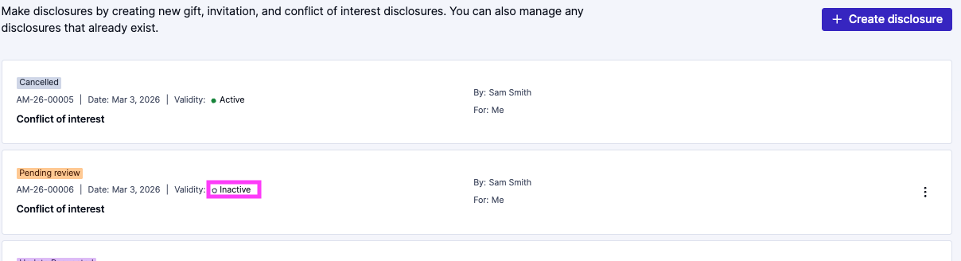

Reactivate a disclosure
Reactivating a disclosure indicates that the conflict of interest is active again, for example if you have resumed working in your second job.
- You will need to find the disclosure that you need to reactivate.
- Note - that it will have validity: inactive.
- Open the disclosure. Click the ‘Reactivate’ button.
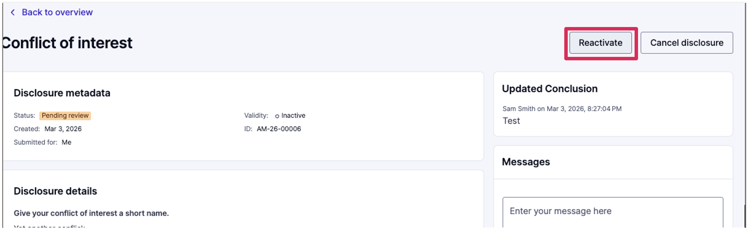
- When you Reactivate a disclosure, you will need to provide a reason for the reactivation and click ‘Confirm‘.
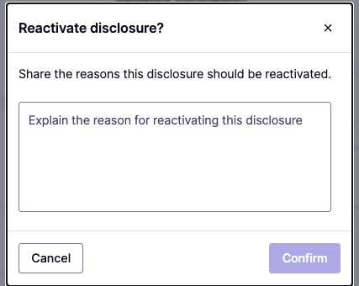

Cancel a disclosure
Cancelling a disclosure indicates that the disclosure was submitted in error.
- Find the disclosure you would like to cancel.
- Open the disclosure.
- Click the ‘Cancel disclosure’ button.
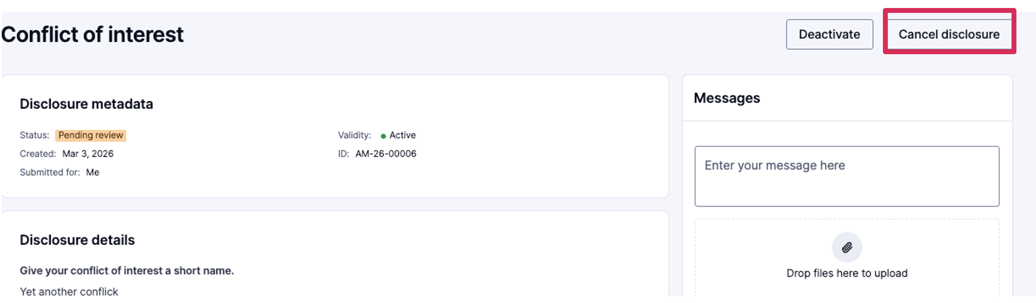
- You will need to confirm you want to cancel the disclosure by clicking the ‘Confirm‘ button.
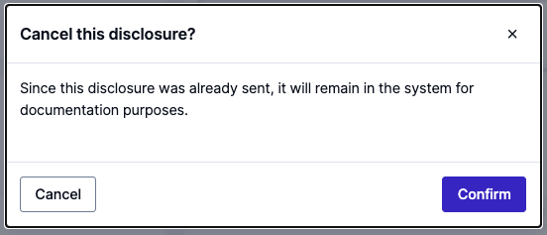
- The disclosure will show as ‘Cancelled’
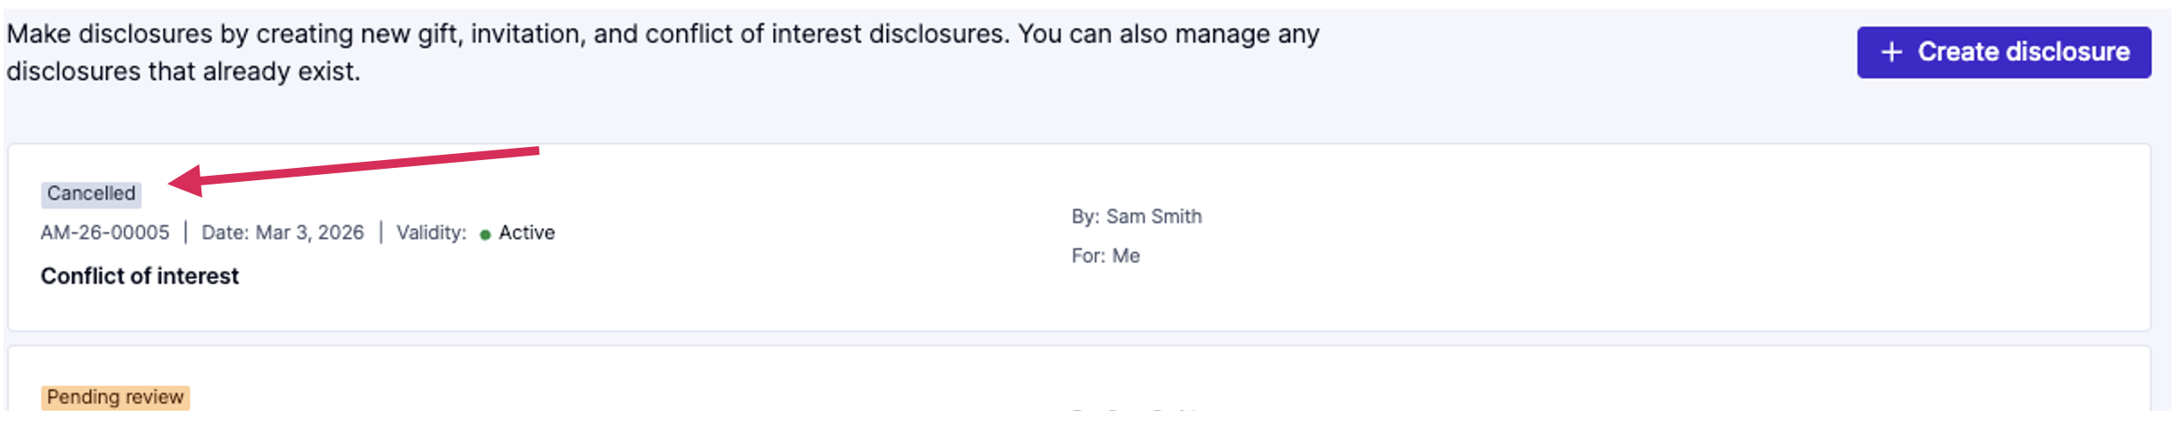

After a disclosure is reviewed
Once your disclosures have been reviewed and a decision has been made, it will display one of four statuses:
- ‘Acknowledged’ – indicating that the disclosure has been acknowledged.
- ‘Approved’ – indicating that the disclosure is approved.
- ‘Approved with Conditions’ – indicating that the disclosure is approved, but there are conditions for the approval.
- ‘Rejected’ – indicating that the disclosure has been rejected.
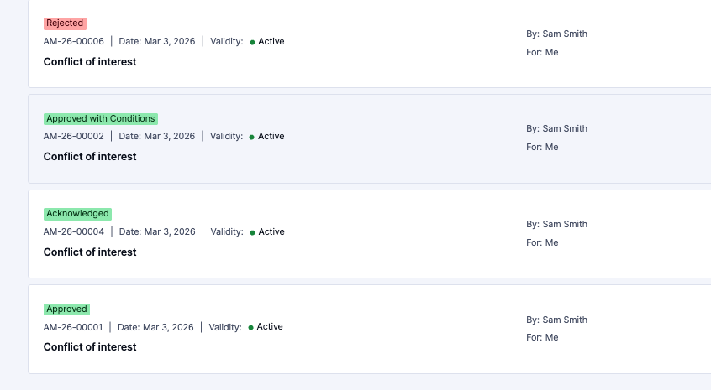

Attestations
You might need to attest to a disclosure that has been approved, approved with conditions, or rejected. This means you have read the decision and agree to any conditions or instructions provided.

Attest to a disclosure
- From the Home screen, you will open the disclosure that needs an attestation by clicking the ‘Attest‘ button.
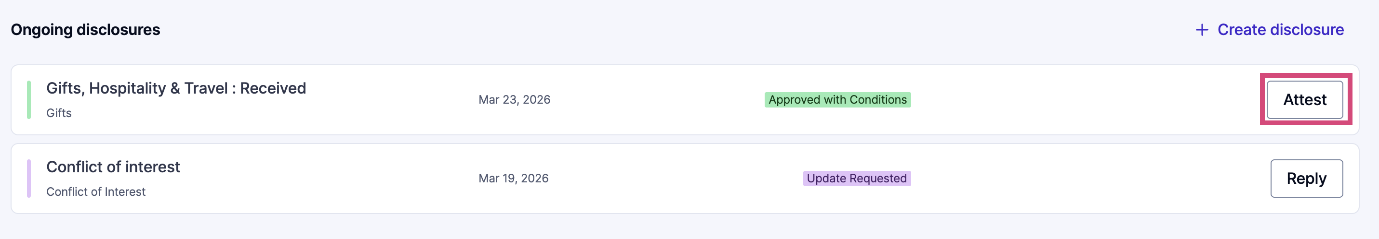
- You may also click ‘Disclosures’ in the menu on the left, finding the disclosures that need attestations. They will have an ‘Attestation pending’ label on the right.
- Click on the disclosure to open it.
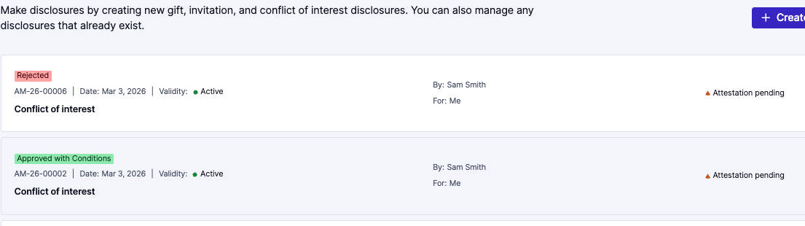
- Review any instructions or information the approver has provided and click on the ‘Confirm’ link in the Attestation pending section.
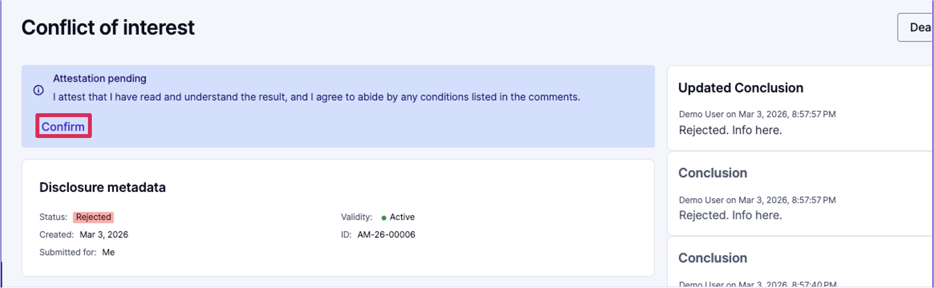
- Once you have clicked ‘Confirm,’ you will see receive a message that the attestation has been completed.
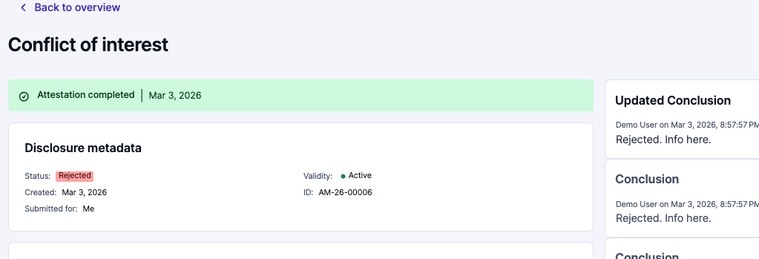
- You will also see that your ‘Attestation pending’ notification on the right has changed to ‘Attestation completed.’
